Snowstorm countermeasures for highways in Hokkaido
Template 1a (E) For numbered-chapter type
Please assume the Proceedings will be opened on HP in the future.
(Delete this text-box when submission)
- Snowbreak forest in Okhotsk Area -

Toshikazu SAWAMATSU¹, Hiroki YUASA¹, Hideki HONDA², Yoshinori KAWASHIMA³,
Masaru MATSUZAWA⁴ and Shuhei TAKAHASHI⁵

¹Abashiri Development and Construction Department, Hokkaido Regional Development Bureau, MLIT, Abashiri, Japan
²Koken Engineering Co., Ltd., Sapporo, Japan
³Docon Co., Ltd., Sapporo, Hokkaido, Japan
⁴Civil Engineering Research Institute for Cold Region, Sapporo, Japan
⁵Okhotsk Sea Ice Museum of Hokkaido, Mombetsu, Japan

Abstract
Recently, snowstorms have become extremely severe in the Okhotsk Area of Hokkaido, Japan. They have ................................................................................................................... ...................... ..................................... and by the Civil Engineering Research Institute for Cold Region.

Key words: road, snowstorm countermeasure, snowbreak forest, snowstorm, traffic hindrance

1. Introduction
Hokkaido is designated as a snowy cold region, and the Okhotsk Area has particularly severe weather in winter. In recent years, snowstorm frequency has been increasing, as have snowstorm disruptions. During snowstorms, many cars become stranded, ...........

2. Snowstorm damage in the Okhotsk area
2.1 Storm paths over Hokkaido
Low-pressure systems that bring heavy snowfall and snowstorms to Hokkaido have various characteristics, depending on their paths (Fukamachi and others, 2004).
There are three major types of low-pressure systems: 1) a low-pressure system .......................................... over the Pacific Ocean as shown in Fig. 1. ..........
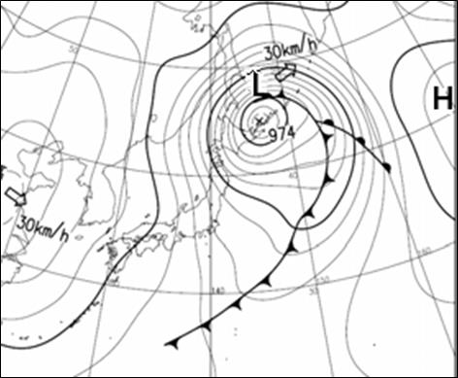
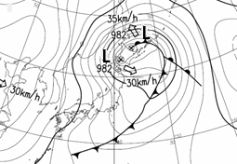
9:00, March 2, 2013
15:00, March 2, 2013

Fig. 1 Low-pressure system with two centers near the Okhotsk District

2.2 Snowstorms and road traffic hindrances in Okhotsk area
Roads in Eastern Hokkaido are frequently closed due to blowing snow. ........ on national highways in Hokkaido (Kawamura and others, 2007; Takahashi and Kosugi, 2010).
...................................................................................
.......................................................................................

5. Conclusion
This paper has explained road traffic disruption in the Okhotsk Area, which has particularly...........
.................................... ..................................................................... .................................. .................................. ............

References
Fukamachi, Y., G. Mizuta and 4 others (2004): Transport and modification processes of dense shelf water revealed by long-term moorings off Sakhalin in the Sea of Okhotsk. J. Geophys. Res. 109: C09S10, doi:10.1029/2003/JC001906.
Ohshima, K.I., T. Watanabe and S. Nihashi (2003): Surface heat budget of the Sea of Okhotsk during 1987-2001 and the role of sea ice on it. J. Meteorol. Soc. Jpn., 81, 653-677.
Kawamura, K., F. Parennin and 16 others (2007): Northern hemisphere forcing of climatic cycles in Antarctica over the past 360,000 years. Nature, 448, 912-916.
Takahashi, S. and T. Kosugi (2010): Sea-ice extent variations along the Okhotsk coast of Hokkaido and Shiretoko Peninsula’s ‘Dam Effect’ against sea ice flow. Proc. 25th Intnatl. Symp. on Okhotsk Sea & Sea Ice, Mombetsu, Japan, 25, 25-28.

(If possible)
Summary in Japanese
...............(Title)...............
.............(Author¹, Author², Author³)...........
.............(¹Affiliation, ²Affiliation, ³Affiliation,)...........
...................................(Abstract)................................
...................................................................................
Correspondence person’s name and mail address
．

Correspondence to: G. R. Demarée, xxxxx@yyyyy.zz

Copyright ©2024 The Okhotsk Sea & Polar Oceans Research Association. All rights reserved.

